KidsBlock Software
Note: We take the Windows system as an example.
Download link: www.kidsbits.net/Down/KidsBlock Desktop 1.1.3 Setup.exe
Double click“KidsBlock 1.1.3 Setup.exe”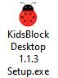，then click“More info”then“Run anyway”.
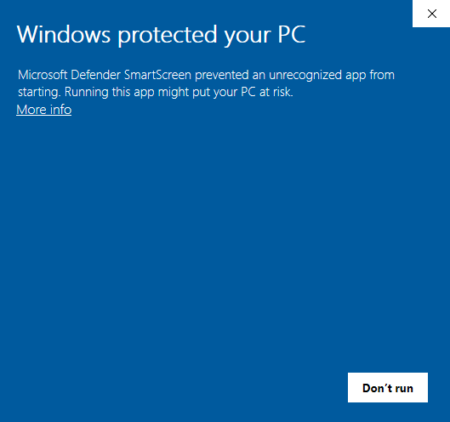

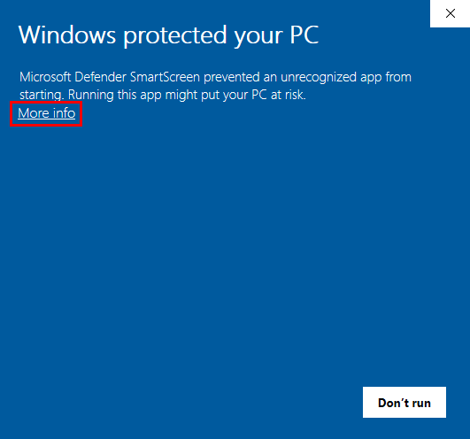

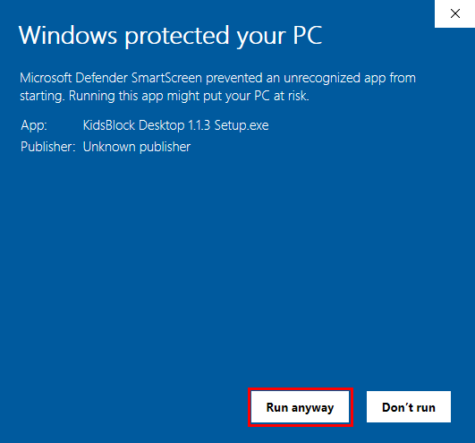

Click“Anyone who uses this computer(all users)”and click“Next”
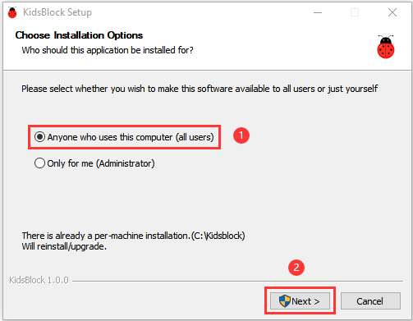
Click“Browse...”and choose the Disk where the software will be placed (here, we choose C Drive). Then click“Install”.
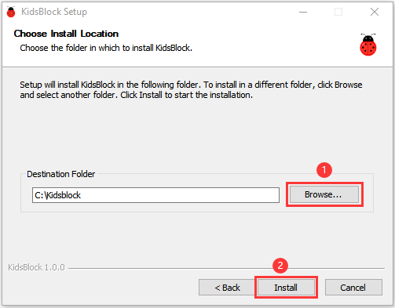
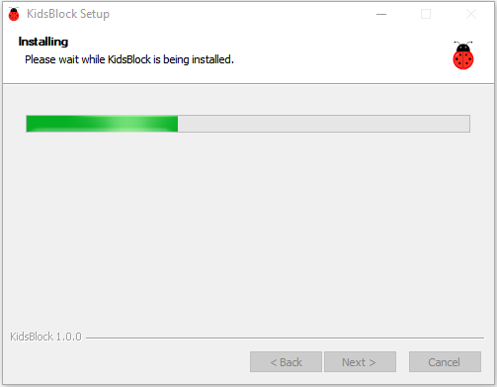
After a few seconds, the installation is complete.
Click "Finish" to open the installed Kidsblock software.
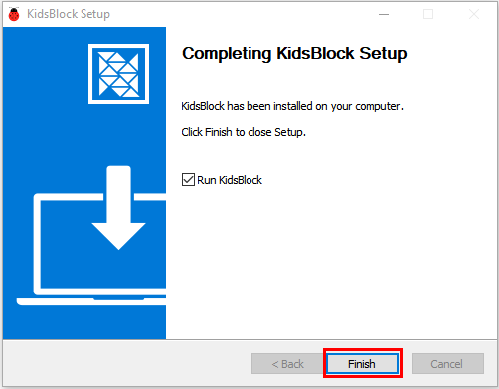

If the computer security alert window appears, click Upgrade and restart to update the latest version of the KidsBlock
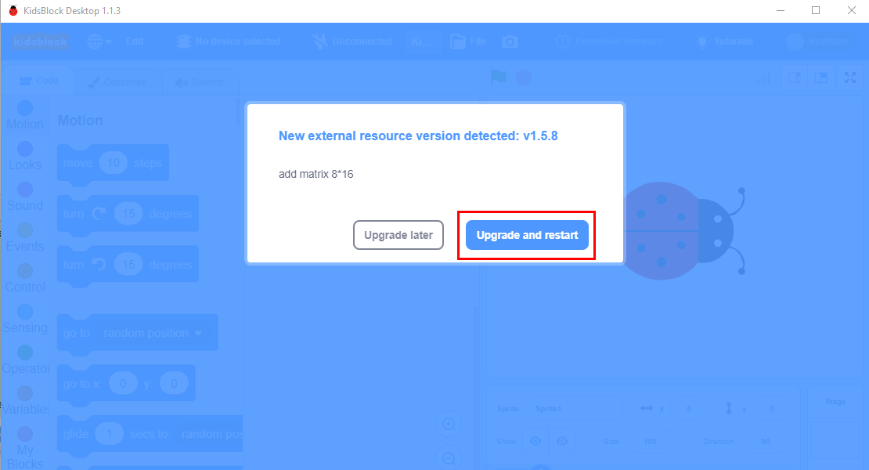
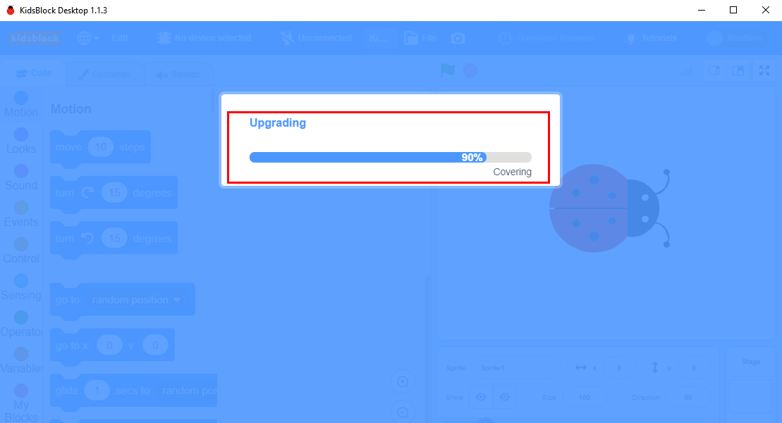

Then open Kidsblock. And click Allow access
